Lesson 3
Chemical methods of analysis
Pharmaceutical analysis is the science of chemical characterization and measurement of biologically active substances at all stages of production: from the control of raw materials to the assessment of the quality of the resulting medicinal substance, the study of its stability, the establishment of expiration dates and the standardization of the finished dosage form. The peculiarities of pharmaceutical analysis are its versatility and variety of substances or their mixtures, including individual chemicals, complex mixtures of biological substances (proteins, carbohydrates, oligopeptides, etc.). Methods of analysis need to be constantly improved, and if chemical methods, including qualitative reactions, prevailed in the UP Pharmacopoeia, then at the present stage, mainly physicochemical and physical methods of analysis are used.
Pharmaceutical analysis, depending on the tasks, includes various aspects of drug quality control:
1. Pharmacopoeial analysis;
2. Stage-by-stage control of the production of medicines;
3. Analysis of individual drugs.
Pharmaceutical Analysis Criteria
For various purposes of the analysis, such criteria as the selectivity of the analysis, sensitivity, accuracy, the time of the analysis, the amount of the test substance are important.
The selectivity of the analysis is essential in the analysis of complex preparations consisting of several active components. In this case, the selectivity of the analysis is very important for the quantitative determination of each of the substances.
The term "analysis accuracy" simultaneously includes two concepts: reproducibility and correctness of the results obtained.
Reproducibility - characterizes the dispersion of the results of the analysis compared to the average value.
Correctness - reflects the difference between the actual and found content of the substance. The accuracy of the analysis depends on the quality of the instruments, the experience of the analyst, etc. The accuracy of the analysis cannot be higher than the accuracy of the least accurate measurement. This means that if the titration is accurate to ±0.2 ml plus leakage error is also ±0.2 ml, i.e. in total ±0.4 ml, then when 20 ml of titrant is consumed, the error is 0.2%. With a decrease in the sample and the amount of titrant, the accuracy decreases. Thus, titrimetric analysis allows determination with a relative error of ± (0.2-0.3)%. Each method has its own accuracy. When analyzing, it is important to have an understanding of the following concepts:
Gross errors - are a miscalculation of the observer or a violation of the analysis methodology. Such results are discarded as unreliable.
Systematic errors - reflect the correctness of the results of the analysis. They distort the measurement results, as a rule, in one direction by some constant value. Systematic errors can be partially eliminated by introducing corrections, instrument calibration, etc.
Random errors - reflect the reproducibility of the results of the analysis. They are called by uncontrolled variables. The arithmetic mean of random errors tends to zero. Therefore, for calculations, it is necessary to use not the results of single measurements, but the average of several parallel determinations.
Absolute error is the difference between the result obtained and the true value. This error is expressed in the same units as the value being determined.
The relative error of the determination is equal to the ratio of the absolute error to the true value of the quantity being determined. It is usually expressed as a percentage or percentage.
The values of relative errors depend on the method by which the analysis is performed and what the analyzed substance is - an individual substance and a mixture of many components.
The relative error in the study of individual substances by the spectrophotometric method is 2-3%, by IR spectrophotometry - 5-12%; liquid chromatography 3-4%; potentiometry 0.3-1%. Combined methods usually reduce the accuracy of the analysis. Biological methods are the least accurate - their relative error reaches 50%.
Chemical methods of authentication.
The identification of medicinal substances by chemical methods is used mainly for inorganic medicinal substances, since other methods are most often not available or they require complex and expensive equipment. As already mentioned, inorganic elements are easily identified by atomic absorption or X-ray spectroscopy. Our Pharmacopoeia Monographs usually use chemical authentication methods. These methods are usually divided into the following:
Precipitation reactions of anions and cations. Typical examples are the precipitation reactions of sodium and potassium ions with (zincuranyl acetate and tartaric acid), respectively:
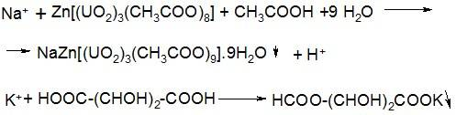
Such reactions are used in great variety and they will be discussed in detail in a special section of pharmaceutical chemistry regarding inorganic substances.
Redox reactions.
Redox reactions are used to reduce metals from oxides. For example, silver from its formalin oxide (silver mirror reaction):
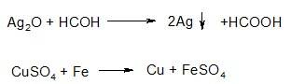
The oxidation reaction of diphenylamine is the basis for testing the authenticity of nitrates and nitrites:
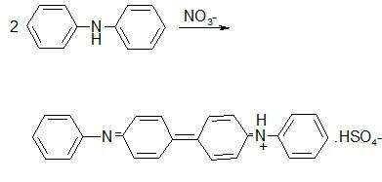
Reactions of neutralization and decomposition of anions.
Carbonates and hydrocarbonates under the action of mineral acids form carbonic acid, which decomposes to carbon dioxide:
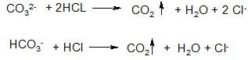
Similarly, nitrites, thiosulfates, and ammonium salts decompose.
Changes in the color of a colorless flame. Sodium salts color the flame yellow, copper green, potassium purple, calcium brick red. It is this principle that is used in atomic absorption spectroscopy.
Decomposition of substances during pyrolysis. The method is used for preparations of iodine, arsenic, mercury. Of the currently used, the reaction of basic bismuth nitrate is most characteristic, which decomposes when heated to form nitrogen oxides:
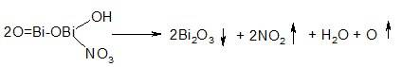
Identification of organoelement medicinal substances.
Qualitative elemental analysis is used to identify compounds containing arsenic, sulfur, bismuth, mercury, phosphorus, and halogens in an organic molecule. Since the atoms of these elements are not ionized, preliminary mineralization is used to identify them, either by pyrolysis, or again by pyrolysis with sulfuric acid. Sulfur is determined by hydrogen sulfide reaction with potassium nitroprusside or lead salts. Iodine is also determined by pyrolysis by the release of elemental iodine. Of all these reactions, the identification of arsenic is of interest, not so much as a drug - they are practically not used, but as a method for monitoring impurities, but more on that later.
Testing the authenticity of organic medicinal substances. The chemical reactions used to test the authenticity of organic medicinal substances can be divided into three main groups:
1. General chemical reactions of organic compounds;
2. Reactions of formation of salts and complex compounds;
3. Reactions used to identify organic bases and their salts.
All these reactions are ultimately based on the principles of functional analysis, i.e. the reactive center of the molecule, which, when reacting, gives the appropriate response. Most often, this is a change in some properties of a substance: color, solubility, state of aggregation, etc.
Let us consider some examples of the use of chemical reactions for the identification of medicinal substances.
1. Reactions of nitration and nitrosation. They are used quite rarely, for example, to identify phenobarbital, phenacetin, dicain, although these drugs are almost never used in medical practice.
2. Reactions of diazotization and azo coupling. These reactions are used to open primary amines. Diazotized amine combines with beta-naphthol to give a characteristic red or orange color.
3. Reactions of halogenation. Used to open aliphatic double bonds - when bromine water is added, bromine is added to the double bond and the solution becomes colorless. A characteristic reaction of aniline and phenol is that when they are treated with bromine water, a tribromo derivative is formed, which precipitates.
4. Condensation reactions of carbonyl compounds. The reaction consists in the condensation of aldehydes and ketones with primary amines, hydroxylamine, hydrazines and semicarbazide:
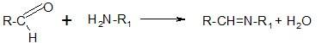
The resulting azomethines (or Schiff bases) have a characteristic yellow color. The reaction is used to identify, for example, sulfonamides. The aldehyde used is 4-dimethylaminobenzaldehyde.
5. Reactions of oxidative condensation. The process of oxidative cleavage and the formation of azomethine dye underlies the ninhydrin reaction. This reaction is widely used for the discovery and photocolorimetric determination of α- and β-amino acids, in the presence of which an intense dark blue color appears. It is due to the formation of a substituted salt of diketohydrindylidene diketohydramine, a condensation product of excess ninhydrin and reduced ninhydrin with ammonia released during the oxidation of the test amino acid:
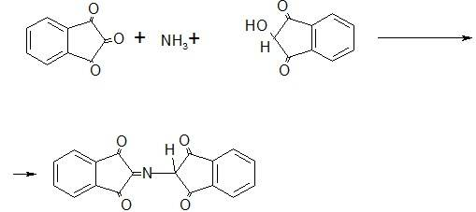
To open phenols, the reaction of the formation of triarylmethane dyes is used. So phenols interacting with formaldehyde form dyes. Similar reactions include the interaction of resorcinol with phthalic anhydride leading to the formation of a fluorescent dye - fluorescein.
Many other reactions are also used.
Of particular interest are reactions with the formation of salts and complexes. Inorganic salts of iron (III), copper (II), silver, cobalt, mercury (II) and others for testing the authenticity of organic compounds: carboxylic acids, including amino acids, derivatives of barbituric acid, phenols, sulfonamides, some alkaloids. The formation of salts and complex compounds occurs according to the general scheme:
R-COOH + MX = R-COOM + HX
The complex formation of amines proceeds similarly:
R-NH2 + X = R-NH2 X
One of the most common reagents in pharmaceutical analysis is a solution of iron (III) chloride. Interaction with phenols, it forms a colored solution of phenoxides, they are colored blue or purple. This reaction is used to discover phenol or resorcinol. However, meta-substituted phenols do not form colored compounds (thymol).
Copper salts form complex compounds with sulfonamides, cobalt salts with barbiturates. Many of these reactions are also used for quantitative determination.
Identification of organic bases and their salts. This group of methods is most often used in ready-made forms, especially in the study of solutions. So, salts of organic amines, when alkalis are added, form a precipitate of a base (for example, a solution of papaverine hydrochloride) and vice versa, salts of organic acids, when a mineral acid is added, give a precipitate of an organic compound (for example, sodium salicylate). To identify organic bases and their salts, the so-called precipitation reagents are widely used. More than 200 precipitating reagents are known, which form water-insoluble simple or complex salts with organic compounds. The most commonly used solutions are given in the second volume of the SP 11th edition. An example is:
Scheibler's reagent - phosphotungstic acid;
Picric acid
Styphnic acid
Picramic acid
All these reagents are used for the precipitation of organic bases (for example, nitroxoline).
It should be noted that all these chemical reactions are used to identify medicinal substances not by themselves, but in combination with other methods, most often physicochemical, such as chromatography, spectroscopy. In general, it is necessary to pay attention to the fact that the problem of the authenticity of medicinal substances is a key one, because this fact determines the harmlessness, safety and effectiveness of the drug, so this indicator needs to be given great attention and it is not enough to confirm the authenticity of the substance by one method.
Determination of the quality of medicines according to these indicators is carried out in several ways:
a) by changing the color of the indicator, for example, an admixture of mineral acids in boric acid is determined by methyl red, which does not change its color from the action of weak boric acid, but turns pink if it contains impurities of mineral acids.
b) titrimetric method - for example, to establish the permissible limit for the content of hydriodic acid formed during storage of a 10% alcohol solution of I2, titration is carried out with alkali (no more than 0.3 ml of 0.1 mol / l NaOH by volume of the titrant). (Formaldehyde solution - titrated with alkali in the presence of phenolphthalein).
In some cases, the Global Fund sets the volume of titrant to determine the acidity or alkalinity.
Sometimes two titrated solutions are added in succession: first an acid and then an alkali.
c) by determining the pH value - for a number of drugs (and necessarily for all injection solutions) according to the NTD, it is envisaged to determine the pH value.
Quantitative analysis of drugs.
The final step in the pharmaceutical analysis of a drug substance is quantitation. It is performed after the drug substance has been identified and the presence of an acceptable amount of impurities has been established. The choice of the optimal method of quantitative determination is determined primarily by its ability to evaluate the medicinal substance by the physiologically active part of the molecule. In practice, this is difficult to do. Usually, the quantitative content of the drug is determined by some of its chemical properties associated with the presence of a particular functional group.
Four groups of methods are used for the quantitative analysis of medicinal substances: chemical, physical, physicochemical and biological.

Chemical methods of quantitative determination.
Gravimetric (weight) method. The method is used mainly for inorganic compounds, rarely for the quantitative determination of some alkaloids in the form of picrates or silicotungstates and vitamins (for example, thiamine bromide and rutin).
titrimetric methods.
Titrimetric (volumetric) methods of analysis are based on an accurate measurement of the amount of a reagent (titrant) consumed in a reaction with a certain substance. During titration, titrant is added in small portions to a solution containing a precisely known mass (weight) of the analyte. After adding each new portion of the titrant in the system described by the chemical reaction equation, an equilibrium is established:
nA + mB = AnBm
where A is the analyzed substance;
B-titrant
n, m are stoichiometric coefficients.
As the reaction proceeds, the equilibrium concentrations of the analyte and titrant decrease, while the equilibrium concentrations of the reaction products increase. When an amount of titrant equivalent to the amount of the titrated substance is consumed, the reaction will end. This moment is called the equivalence point. In practice, the end point of the titration (reaction) is fixed. Which, with some degree of approximation, corresponds to the equivalence point. In titrimetric methods of analysis, it is fixed visually by a noticeable analytical effect (change in color of the solution, precipitation) caused by any of the starting compounds, reaction products, or substances specially added to the solution - indicators. In physico-chemical methods of analysis, the end point of the titration, as we have already said. determined by some factor.
Reactions used in titrimetry must meet the following basic requirements:
- the reaction must proceed quantitatively, that is, the equilibrium constant of the reaction must be sufficiently high;
- the reaction must proceed at a high rate;
– the reaction should not be complicated by side processes;
– there must be a way to determine the end point of the titration.
If a reaction does not satisfy at least one of these requirements, it cannot be used in titrimetric analysis.
In titrimetry, there are three methods of titration: direct, reverse and indirect (substitutive).
In direct titration, analyte A reacts directly with titrant B:
A + B = C
If such a reaction is impossible for some reason (there is no chemical interaction of the analyte with the titrant, the reaction proceeds at an insufficiently high rate, there is no reliable way to determine the end of the titration, etc.), then the reverse or indirect method is used.
In Back titration, an excess of titrant B is added to the analyte, the unreacted residue of which is titrated with titrant D:
A + B = C
Excess
B + D = E
In INDIRECT (substitutive) titration with titrant B, the product of the intermediate reaction G of the analyte A reacts with the auxiliary reagent F:
A + F = G
G + B = K
For titration, titrimetric methods use solutions of exactly known concentration, called TITRANTS or TITRATING SOLUTIONS. The concentration of a titrated solution is denoted by the terms MOLAR, NORMAL, TITER or TITTER FOR THE SUBSTANCE TO BE DETECTED.
MOLAR CONCENTRATION is the number of moles of a solute contained in one liter of solution. It is calculated as the ratio of the amount of solute to the volume of the solution in liters (the unit is mol/l). A mole is the amount of a substance that contains as many specified structural units as there are atoms in 0.012 kg (12 g) of the carbon-12 isotope.
Elementary particles, as well as ions, atoms, molecules or their fractions can be chosen as specified structural units. In analytical chemistry, these fractions are chosen so that each of them is responsible for the transfer of one electron in a redox reaction or is equivalent to one hydrogen ion in an acid-base reaction. To designate such a fraction of an ion, atom or molecule, the term "conditional particle" is adopted. The conditional particle is otherwise called the EQUIVALENT. The molar concentration of titrated solutions was adopted by the SP X1 edition in accordance with the IUPAC recommendation.
In analytical practice, along with the molar concentration of solutions, the normal concentration of the solution is also used.
NORMAL CONCENTRATION of a solution is the number of moles of solute equivalent contained in one liter of solution. A solution containing 1 mole equivalents of substances A in 1 liter is called a normal solution of this substance and denoted - 1n.
TITR is the mass of a solute, expressed in grams, contained in 1 milliliter of a solution. The titer is calculated as the ratio of the mass of the solute to the volume of the solution (dimension g/ml).
The titer of the titrant by the analyte is the mass of the analyte expressed in grams, equivalent to one milliliter of the given titrant (dimension g/ml). The titer for the analyte (T V / A) is calculated by the formula:
T \u003d N E / 1000,
Where N is the normal (molar) concentration of the titrant;
E-molar mass of the equivalent of the analyte.
The molar mass of the equivalent of a substance denotes the mass of one mole of the equivalent of this substance, equal to the product of the equivalence factor (feq) by the molar mass of the substance.
An equivalence factor is a number indicating what proportion of a molecule of a substance is equivalent to one hydrogen ion in a given acid-base reaction or one electron in a given redox reaction.
For example, when titrating sodium carbonate with a titrated solution of hydrochloric acid, it follows from the chemical reaction equation that fequiv (Na2CO3) = 1/2
Na2CO3 + 2HCl = 2NaCl + CO2 + H2O
The calculation of the quantitative content of the analyzed individual substance in% (X) is carried out according to the formulas:
- Direct and indirect (replacement titration):
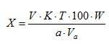
where V is the volume of titrant used for titration, ml;
K-correction factor of the titrated solution (titrant);
T-titer of the titrant for the analyte
a-mass of the analyte, taken for analysis (sample), g;
W is the volume of the volumetric flask, ml;
Va is the volume of the solution taken for titration (volume of the pipette), ml.
- BACK titration
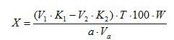
where V1 is the volume of titrant taken in excess, ml;
V2 is the volume of titrant used for titration of the excess of the first titrant, ml;
K1, K2 - correction factors for titrated solutions.
If a control experiment is carried out during the quantitative determination (for the titrant and for the indicator), then formulas 2 and 3 take the form:
- Direct and indirect titration
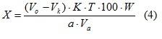
- Back titration
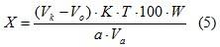
where Vо is the volume of titrant used during titration in the main experiment, ml;
Vk is the volume of titrant used for titration in the control experiment, ml.
Titration methods used in pharmaceutical chemistry are usually divided into:
1. Acid-base titration (in aqueous and non-aqueous media);
2. Methods of oxidation-reduction (redoxmetry);
3. Methods of precipitation titration;
4. Complexometric titration;
5. Nitritometry.

Acid-base titration
In an aqueous medium, the reaction between an acid and a base can be represented by the equation:
H₃O+ + OH– = 2H₂O
Strong acids (hydrochloric acid, sulfuric acid) are used as titrants - acidimetry; or strong bases (caustic soda, caustic potash) - alkalimetry.
Alkalimetry is used for the quantitative determination of medicinal substances, which are:
– inorganic and organic acids;
– salts of organic bases (hydrochlorides, nitrates, hydrophosphates, lactates, hydrotartrates, etc.).
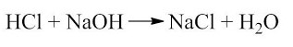
Acidimetry is used to determine:
- organic bases that exhibit basic properties in aqueous or alcoholic media;
- sodium salts of weak inorganic and organic acids.
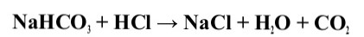
One of the acid-base titrations used is the combination of a neutralization reaction with pre-esterification or hydrolysis. Some medicinal substances, derivatives of alcohols or phenols are acetylated with acetic anhydride (an ester is formed). Excess acetic anhydride is converted to acetic acid and titrated with alkali. The possibility of using the acid-base titration method for the analysis of medicinal substances is determined by the dissociation constant of the titratable substance and its concentration in the solution.
The magnitude of the titration jump on the titration curve depends significantly on the dissociation constant. When determining medicinal substances by the method of neutralization, Ka and Kv of acids and bases must be at least 10-7. Thus, when titrating 0.1 mol/l solutions of strong acids and alkalis, the titration jump is about 6 pH units; if Ka(Kv) = 10-3, then 3-4 pH units; at Ka(Kv) = 10-5, 2-2.5 pH units; at Ka(Kv) = 10-9–10-10, there is no titration jump and determination of the titration end point becomes practically impossible.
When titrating a 0.1 mol/l solution of a strong acid with an alkali solution and vice versa, the titration jump is about 6 pH units, at a concentration of 0.01 mol/l, respectively, 3.4 pH units; at 0.001 mol/l - 1.4 pH units; at 0.0001 mol/l there is no titration jump.
Mixed solvents are used to enhance the acid-base properties of analytes and also when the drug is poorly soluble in water (for example, titration of sulfanilamide preparations with a dissociation constant of 10-7-10-8 (norsulfazol).
Titration in non-aqueous solvents.
The method of acid-base titration in non-aqueous solvents is used for the quantitative determination of weak acids (barbiturates, sulfonamides), weak bases (caffeine, reserpine). Salts of organic bases. This method allows the determination of many medicinal substances that, when titrated in aqueous solutions, do not have a clearly defined end point of the titration. Under the influence of non-aqueous solvents, the acid-base properties of various substances change. Depending on the solvent, the same substance can become an acid, a base, an amphoric or neutral compound, a strong or weak electrolyte. The strength or weakness of an acid or base is determined by the nature of its interaction with the solvent. In the acid-base process, all solvents are divided into two large groups: APROTIC and PROTOLYTIC.
Aprotic solvents are chemical compounds of a neutral nature, the molecules of which are not ionized and are not capable of either donating or adding a proton. Aprotic solvents do not interact with the substance dissolved in them. Such solvents include hydrocarbons (benzene, toluene, hexane) and their halogen derivatives. Aprotic solvents are often added to the titrated solution to suppress the process of solvolysis of neutralization products, which contributes to a clearer determination of the end point of the titration.
Protolytic solvents are chemical compounds whose molecules are capable of donating or accepting protons. They are involved in the acid-base process. Protolytic solvents, in turn, can be divided into three groups:
Amphiprotic - amphoteric, capable of both donating and accepting a proton. Water, alcohols.
Protogenic or acidic solvents. Substances in which the ability to donate a proton significantly exceeds the ability to attach it. Acetic acid, formic acid. Protogenic solvents enhance the basic properties of chemical compounds.
Protophilic or basic solvents. Liquid ammonia, pyridine, DMF, and other protophilic solvents enhance the acidic properties of weak acids and amphoteric compounds.
A typical example is the titration of potassium acetate in anhydrous acetic acid with perchloric acid.
Titration in protophilic solvents is carried out with potassium or sodium methylates in pyridine.
Redox Titration Methods
These methods are based on the use of redox reactions. In the process of titration, the redox potentials of interacting systems change. If the potential difference is large enough (0.3-0.4 V), then the redox process proceeds to the end (therefore, it is possible to use the direct titration method). The end points of the titration are set using special indicators (ferroin, diphenylamine), dissolved starch - when titrated with iodine, indicators that irreversibly lose color in excess of an oxidizing agent (methyl orange), the non-indicator method in permanganatometry and the electrochemical method.
In pharmaceutical chemistry, the following methods are used:
1. Iodimetry
2. Iodometer
3. Iodine chlorometry
4. Bromatometry
5. Permanganatometry
6. Cerimetry
Iodatometry
The method is based on the use of a solution of potassium iodate as a titrant, which is a strong oxidizing agent in an acidic environment. The method is based on a chemical reaction:
IO3– + 6H+ +6e = I– + 3H2O =
From this equation it follows that when preparing a titrated solution of potassium iodate, the value of the molar mass of the equivalent is taken into account, equal to 1/6 of the molar mass of potassium iodate. The iodatometric method is recommended for the quantitative determination of ascorbic acid:
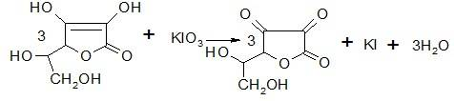
At the end of the titration point, an excess of titrated potassium iodate solution leads to the oxidation of the iodide ion in an acidic environment and the resulting iodine turns the starch blue.
Iodine chlorometry. A solution of iodine monochloride obtained from iodine and potassium iodate in an acidic medium is used.
ICl + KI → I₂ + KCl
I₂ + 2Na₂S₂O₃ → 2NaI + Na₂S₄O₆
Bromatometry. Potassium bromate solution is used as a titrant.
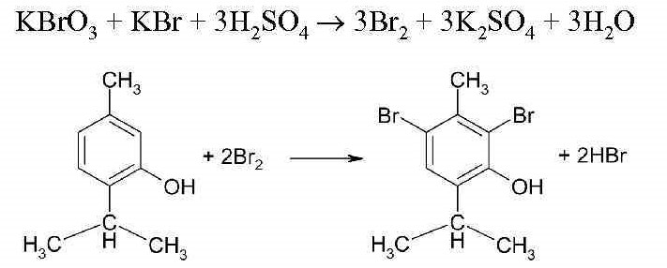
Permanganatometry. The method is based on the oxidation of the analyte by permanganate ions. The titration is carried out in a strongly acidic medium.
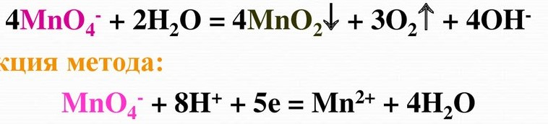

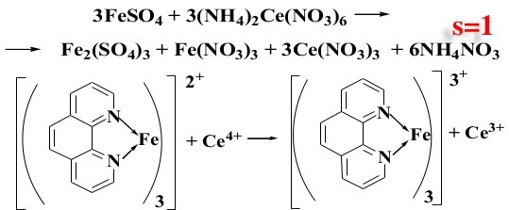

Precipitation titration. Argentometric titration.
Faience method.
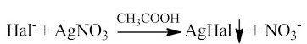
Mohr method.
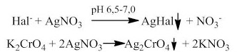
Folgard's method.
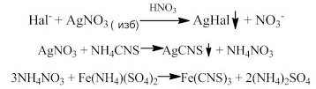
Argentometric titration is based on the precipitation of halides with a solution of silver nitrate (titrant). The end point of the titration is set using INDICATORS:
1.forming colored precipitation;
2. Forming colored complexes;
3.Adsorption indicators;
4. Potentiometrically.
This method determines inorganic substances containing halogens. As indicators, for example, potassium chromate is used, which at the end of the titration forms a brick-red precipitate of silver chromate. The solubility constant of silver chromate is much higher. Than chloride, therefore, an insoluble precipitate of silver chloride is initially formed.
Complexometric titration.
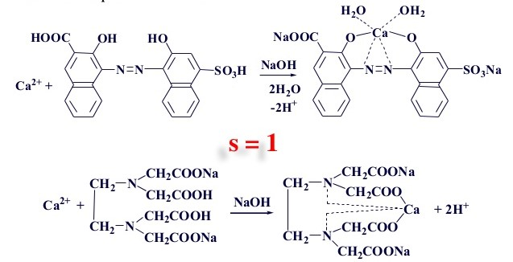

The method of complexometric titration is based on the reaction of the formation of chelate compounds of metal ions with special complexing reagents called complexones.
Nitritometry. Method for the quantitative determination of primary aromatic amines. Based on the diazotization reaction. The end point of the titration in nitritometry is set:
1. Using internal indicators: RO tropeolin, neutral red.
2. With the help of external indicators - starch iodine paper.
